St Philip’s Catholic Primary School

Behaviour Policy
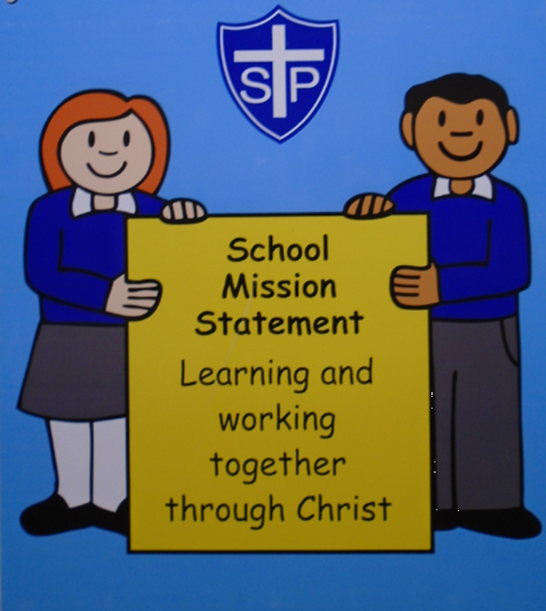
Please also see our Safeguarding, Online Safety Policies, Suspension and Exclusions Policy and SEND policy

Our School Mission Statement is :
Learning and working together through Christ

Statement of intent

St Philip’s Catholic Primary School believes that, in order to facilitate teaching and learning, acceptable behaviour must be demonstrated in all aspects of school life to respect the dignity of each person as people of God.

The local governing body and staff at our school are committed to:

- Creating a positive and nurturing learning environment to promote positive behaviour and discipline with clear guidelines.
- Building self-esteem, self –discipline and positive relationships based on mutual respect and the example of Jesus Christ.
- Promoting self-esteem, self-discipline, regard for authority and positive relationships based on mutual respect.
- Ensuring equality and fair treatment for all.
- Ensuring that all children can learn and work in an environment promoting clear guidelines in praising and rewarding good behaviour.
- Using behaviour tracking, recording and monitoring systems to enable timely intervention and support where needed to promote positive behaviour and discipline.
- Providing a safe environment, free from disruption, violence, discrimination, bullying, intimidation and any form of harassment.
- Encouraging positive and trusting relationships with parents/carers to develop a shared approach to their child’s education which involves them in the implementation of all aspects of the policy and other related polices.
- Developing positive relationships with our pupils to enable early intervention.
- Promoting desired behaviour by working with a diverse range of outside agencies and professionals to ensure the needs of all children and young people are met.
- A shared approach which involves pupils in the implementation of the school’s policy and associated procedures.
- Promoting a culture of praise and encouragement in which all pupils can achieve.
- To develop the whole child intellectually, physically, emotionally, socially, morally and spiritually.

Signed by:
C.HINTON | Principal | Date:
S.GODBER | Chair of governors | Date:

Legal framework
  - This policy has due regard to all relevant legislation and statutory guidance including, but not limited to, the following:
  - We as a school are committed to ensuring that everyone is treated equally and fairly, promoting the equal opportunities policy regarding the 9 protected characteristics in the Equality Act (2010)
- The Education Act 1996
- The Education Act 2002
- The Equality Act 2010
- The Education and Inspections Act 2006
- The Health Act 2006
- The School Information (England) Regulations 2008
- DfE ‘Behaviour and discipline in schools’ 2022
- DfE ‘Sexual violence and sexual harassment between children in schools and colleges’ 2021
- Keeping Children Safe in Education 2023

Roles and responsibilities
  - The Academy Committee at St Philip’s Catholic Primary has overall responsibility for:
- The implementation of this Behavioural Policy and of the behaviour procedures at the school.
- Ensuring that this policy, as written, does not discriminate on any grounds, including, but not limited to, ethnicity/national origin, culture, religion, gender, disability or sexual orientation.
- Handling complaints regarding this policy, as outlined in the school’s Complaints Policy that can be accessed via the school’s website.
  - The Principal is responsible for:
- Establishing the standard of behaviour expected by pupils to promote a calm and safe ethos at the school.
- Determining the school rules and any appropriate disciplinary sanctions where school rules and the school’s mission statement are not adhered to.
- The day-to-day implementation of this policy.
- To promote positive attitudes and motivation to ensure that behaviour and attendance is of a high standard
- Publishing this policy and making it available to staff, parents/carers and pupils regularly.

2.3 All members of staff, volunteers and support staff are responsible for:
- To provide a secure learning environment this ensures the health and safety of everyone in the school.
- To encourage respect and tolerance for all, regardless of race, culture, gender or disability.
- To encourage the development of independence and the fostering of self discipline, cooperation, tolerance and respect for others.
- To ensure that the established school rules are implemented and that the rewards and sanctions are known by staff, children, parents and governors.

- To teach the Catholic School’s Pupil Profile alongside the Catholic Social Teaching principles through the whole school curriculum.
- Promoting a supportive and high-quality learning environment and modelling high levels of behaviour so that pupils know that they are well cared for.
- Adhering to this policy and ensuring that all pupils do too.
  - Pupils are responsible for:
- Living out the school mission statement through their own behaviour both inside school and out in the wider community.
- To have high expectations of their own behaviour and follow the established school rules.
- Recognising any unacceptable behaviour and informing a member of staff.
- To move sensibly, politely and quietly in and around school.
- To have a driven desire to apply the Catholic Social Teaching values along with the Catholic School’s Pupil Profile to contribute to a safe and happy environment.
  - Parents are responsible for:
  - Parents are responsible for the behaviour of their child(ren) inside and outside of school in line with this policy and our home/ school agreement.
  - Making the school aware of any concerns that may impact upon a child’s behaviour.
  - Supporting the school’s mission statement and behaviour expectations.
  - Modelling behaviour expectations through their own behaviour within the school grounds.
  - To ensure children attend school regularly and arrive on time each day.
  - To encourage independence and self discipline in their children.
  - To establish good communication with school staff and support the behaviour policy.
  - To encourage respect and good behaviour and to make their children aware of inappropriate behaviour in line with the school ethos.
  - To work with school staff to address and review any behaviour issues with their children.
  - To adhere to GDPR/online safety policy by showing respectful behaviour at school events, respecting the privacy of children not taking any videos or photographs.
  - To have regular discussions with teachers where appropriate to discuss incidents within school.

Values
We nurture the unique God-given talents of every individual, providing a quality, distinctively Catholic education to our diverse community.
Our core values are inspired by Catholic Social Teaching and are rooted in the person and teaching of Jesus Christ as the model for human excellence.
Our relationships and daily dealings with each other should be characterised by:
- Care for each other
- Compassion
- Trust and respect for the dignity and value of each individual
- Stewardship of the earth
- Solidarity and subsidiarity: a commitment to stand with each other in support of each other

Our school has its own set of values pertinent to each community. School values are rooted in the MAC virtues and the Catholic Schools Pupil Profile.
The Virtues of the Catholic Schools Pupil Profile
All of our schools live by and explicitly teach and promote the virtues of the Archdiocese of Birmingham’s Catholic Schools Pupil Profile:
Children and young people in the Archdiocese of Birmingham are growing to be . . .

Grateful for their own gifts, for the gift of other people, and for the blessings of each day; and generous with their gifts, becoming men and women for others.

Attentive to their experience and to their vocation; and discerning about the choices they make and the effects of those choices

Compassionate towards others, near and far, especially the less fortunate; and loving by their just actions and forgiving words.

Faith-filled in their beliefs and hopeful for the future.

Eloquent and truthful in what they say of themselves, the relations between people, and the world.

Learned, finding God in all things; and wise in the ways they use their learning for the common good

Curious about everything; and active in their engagement with the world, changing what they can for the better.

Intentional in the way they live and use the resources of the earth, guided by conscience; and prophetic in the example they set to others.

We also root our values in the Catholic Social Teachings so that our pupils think about:

The common good so that everyone is treated fairly and no one is left out.

Solidarity so we all learn and work together in Christ.

The dignity of the human person as we treat everyone with the same respect as people of God.

The dignity of work as we all strive to do our best in all that we do.

Option for the poor and vulnerable in order to help all those in our community and in our world that need our support.

Rights and responsibilities as we know that we all have the right to live safely and the responsibility to be safe with others.

Stewardship as we all care for God’s creations, including each other and the world we live in.

Routines
Routines are a key means by which our schools teach and reinforce the behaviours expected of all pupils. Repeated practices promote the values of the school, positive behavioural norms and certainty on the consequences of unacceptable behaviour. We ensure that any aspect of behaviour expected from pupils is made into a commonly understood routine, for example behaviour and conduct expectations when coming into the hall for prayer and liturgy, coming into the classroom, clearing tables at lunchtime. Routines must be simple or everyone to understand and follow.

Adjustments to routines or pupils with additional needs

Our schools adjust routines for pupils with additional needs where appropriate and reasonable, to ensure all pupils can meet behavioural expectations. These adjustments may be temporary. Adjustments are made proactively and by design where possible (for example, a pupil who has suffered a bereavement may need to be pre-emptively excused from a routine to give them time and space away from their peers). Adjustments needed for pupils with special educational needs and / or disabilities (SEND) are covered in the separate SEND sections and policies. We are completely mindful of the fact that not all pupils requiring support with behaviour will have identified special educational needs or disabilities.

Points of transition
Pupil transitions into formal school in nursery and reception class and to secondary education between school year 6 and 7 are carefully managed and involve parents and carers at every stage.
All staff must understand the importance of effective transitions and provide personalised interventions to support pupils. All of our schools are expected to liaise with parents and carers and work closely with other settings such as pre-schools, day nurseries and former schools. Primary schools must work closely on transition with all of the secondary school settings where the pupils from a cohort are transferring to at the end of year 6.
Our secondary schools must work closely with all of their feeder primary schools to ensure smooth transition. Effective transition arrangements must ensure pupils quickly understand the behaviour policy and individual school behaviour procedures.

Our school has a clear set of transition arrangements in place.

Monitoring and evaluating school behaviour
Each of our schools in the Emmaus Multi Academy Company must have strong and effective systems for data capture, including all components of the behaviour culture. Data must be monitored and analysed objectively by skilled staff. All of our schools are required to have a clear monitoring and evaluation cycle on the Arbor MIS system with full engagement from senior staff, this enables leaders to report clearly and accurately on behaviour and culture. The focus is on regularly evaluating data and proactively making changes to the behaviour culture where required in response to behaviour data.

Our expectations

We believe our expectations for positive behaviour give protection to children’s rights. These expectations are regularly reviewed and discussed with pupils and staff. Our expectations are clear, positively phrased, fair, reasonable and unambiguous. When staff are supporting pupils whose behaviour falls short of our expectations, it is clearly explained to them which expectation/s are not being adhered to. School expectations have been created in consultation with staff and pupils and are contextualised to meet the needs of individual pupils through school’s positive behaviour procedures.

Behaviour expectations of pupils with special educational needs and / or disability

The culture in our schools should actively promote high standards of behaviour and provide the necessary support to ensure pupils can achieve and thrive both in and out of the classroom. Each staff member must evaluate how the whole school approach meets the needs of all pupils in the school, including pupils with SEND. Our approach must ensure everyone feels they belong to the school community and ensure high expectations are maintained for all pupils.
Some behaviours are more likely to be associated with particular types of SEND, such as a pupil with speech, language and communication needs who may not understand a verbal instruction. Behaviour will often need to be considered in relation to a pupil’s SEND though we must remember not every incident of misbehaviour will be connected to their SEND.
Pupils’ behaviour must be managed effectively, whether or not the pupil has SEND. Where a pupil is identified as having SEND, the graduated approach should be used to assess, plan, deliver and review the impact of the support being provided (for their behaviour).

The law requires schools to balance a number of duties which have bearing on the behaviour policy and practice, particularly where a pupil has SEND that at times affects their behaviour. Schools have duties under the Equality Act 2010 to take such steps as is reasonable to avoid any substantial disadvantage to a disabled pupil caused by the school’s policies or practices. Schools have duties under the Children and Families Act 2014 to use their ‘best endeavours’ to meet the needs of those with SEND and if a pupil has an Education, Health and Care Plan (EHCP) the provisions set out in that plan must be secured and the school must co-operate with the local authority and other bodies.
As part of meeting these duties our schools will, as far as possible, anticipate the likely triggers of misbehaviour and put in place support to prevent these. For example:
- Short, planned movement breaks for a pupil whose SEND means they find it difficult to sit still for long
- Adjusting seating plans to allow a pupil with a visual or hearing impairment to sit in sight of the teacher
- Adjusting uniform requirements for a pupil with sensory issues or who has severe eczema
- Training for staff in understanding conditions such as autism

Definitions specifically around behaviour
Positive behaviour is defined as :
- Consistent good manners and calling everyone by their given name
- Willingness to help each other learn / or helping an adult
- Having respect and consideration for adults and children / young people
- Consistent effort for work in class
- Completing homework task and projects to promote learning
- Completing a set independent task or Pink to think /NOW task
- Participating in class discussion. Mass and hymn practice
- Good self-management in school
- Recognition and respect for authority by following instructions
- Honesty to peers and adults
- Ability to forgive and become reconciled after quarrels or upsets
- Sharing and caring
- Unselfish play
- Responsible and reliable behaviour
- Displaying positive learning behaviours

Misbehaviour is defined as:
- Disruption in lessons, in corridors between lessons and at break and lunchtimes
- Non completion of class work or homework
- Hurting a friend with unkind words, hands or feet
- Poor attitude or responses to adults and peers
- Not following instructions by adults.
- Poor attitude to work and classroom expectations
- Leaving the classroom or safe environment without permission

Serious misbehaviour is defined as:

For the purpose of this policy, the school defines “serious unacceptable behaviour” as any behaviour which may cause harm to oneself or others, damage the reputation of the school within the wider community, and/or any illegal behaviour, including, but not limited to, the following:
  - Discriminatory bullying – not giving equal respect to an individual on the basis of disability, gender, race, religion, age, sexuality and/or marital status
  - Harassment – behaviour towards others which is unwanted, offensive and affects the dignity of the individual or group of individuals
  - Vexatious behaviour – deliberately acting in a manner so as to cause annoyance or irritation
  - Bullying – a type of harassment which involves criticism, personal abuse or persistent actions which humiliate, intimidate, frighten or demean the individual
  - Cyberbullying – the use of electronic communication to bully a person, typically by sending messages of an intimidating or threatening nature
  - Prejudice-based bullying - when bullying behaviour is motivated by prejudice based on an individual’s actual or perceived identity; it can be based on characteristics unique to a child or young person’s identity or circumstance.
  - Repeated breach of the school rules
  - Refusal to work
  - Throwing objects
  - Possession of legal or illegal drugs, alcohol or tobacco
  - Smoking /vaping
  - Possession of banned items
  - Truancy
  - Refusing to comply with disciplinary sanctions
  - Theft
  - Swearing, racist remarks or threatening language
  - Malicious allegations
  - Fighting or aggression
  - Vandalism
  - Deliberate disobedience – insolence
  - Endangering others in any way
  - Child on child abuse
  - Physical assault of any kind towards another pupil, staff or visitors
  - Endangering the safety of themselves, other children and staff – carelessly or with intent
  - Speaking disrespectfully or holding disrespectful attitudes towards others, including (but not limited to) on the basis of someone’s protected characteristics (Age, Disability, Gender reassignment, marriage and civil partnerships, pregnancy or maternity, race, religion or belief, sex and sexual orientation
  - Any form of bullying
  - Criminal behaviour
  - Sexual violence and abuse
  - Absconding from school
  - Racist, sexist, homophobic or discriminatory behaviour (also see protected characteristics above) Possession of any prohibited items (as per subsection (3) of Section 550ZA of the Education Act 1996:
  - Knives or weapons
  - Alcohol
  - Illegal drugs
  - Stolen items
  - Tobacco, cigarettes, cigarette papers,
  - Fireworks
  - Pornographic images
  - Any article a staff member reasonably suspects has been, or is likely to be, used to commit an offence, or to cause personal injury to, or damage the property of any person (including the pupil themselves

Serious misbehaviour: Suspected criminal behaviour

In cases where criminal behaviour is suspected, schools should make an initial assessment of whether an incident should be reported to the police by gathering enough information to establish the facts of the case. Initial investigations must be fully documented and preserved. Once a decision is made to report the incident to the police, further action taken by the school must not interfere with any police action taken. However, schools retain the discretion to continue investigations and enforce their own sanctions so long as it does not conflict with police action.
When making a report to the police it will most often be appropriate to make in tandem a referral to Children’s Services in the LA where the child is resident. It is expected in most cases that this would be led by the Designated Safeguarding Lead (DSL) or deputy designated safeguarding lead.
Keeping Children Safe in Education Part 5 provides guidance on reporting child on child sexual violence and abuse.

Serious misbehaviour: Child on child abuse

Abuse is not only perpetrated by adults; children can abuse other children and it can happen both inside and outside of school and online. This is referred to as peer on peer abuse and can include:
- Bullying, including cyberbullying, prejudice-based and discriminatory bullying.
- Verbal abuse in relationships between peers which leads to emotional upset, anxiety and fear
- Physical abuse such as hitting, kicking, shaking, biting, hair pulling or otherwise causing physical harm; this may include an online element which facilitates, threatens and / or encourages physical abuse
- Sexual violence, such as assault by penetration and sexual assault; this may include an online element which facilitates, threatens and / or encourages sexual violence.
- Sexual harassment, such as sexual comments, remarks, jokes and online sexual harassment, which may be standalone or part of a broader pattern of abuse.
- Causing someone to engage in sexual activity without consent.
- Consensual and non-consensual sharing of nude and semi-nude images or videos (also known as sexting or youth produced sexual imagery)
- Upskirting – which involves taking a picture under someone’s clothing without them knowing; this is usually with the intention of viewing their genitals or buttocks for sexual gratification, or to cause the victim humiliation, distress or alarm. Upskirting is a criminal offence and anyone of any gender can be a victim.
- Initiation / hazing type violence and rituals.
Please also refer to schools’ Anti Bullying Policy and Safeguarding Policy and Procedures.

Serious misbehaviour: Bullying
St Philip’s Catholic Primary School and The Emmaus MAC understands bullying from the Anti Bullying Alliance definition:
‘The repetitive, intentional hurting of one person or group by another person or group, where the relationship involves an imbalance of power. Bullying can be physical, verbal or psychological. It can happen face-to-face or online’.
There are four key elements to this definition:
- hurtful
- repetition
- power imbalance
- intentional
Bullying behaviour can be:
- Physical – pushing, poking, kicking, hitting, biting, pinching etc.
- Verbal - name calling, sarcasm, spreading rumours, threats, teasing, belittling.
- Emotional – isolating others, tormenting, hiding books, threatening gestures, ridicule, humiliation, intimidating, excluding, manipulation and coercion.
- Sexual – unwanted physical contact, inappropriate touching, abusive comments, homophobic abuse, exposure to inappropriate films etc.
- Online /cyber – posting on social media, sharing photos, sending nasty text messages, social exclusion
- Indirect - Can include the exploitation of individuals.

Serious misbehaviour: Absconding from school

To abscond is to leave the school site without permission. If a pupil leaves a school site without permission, the school’s safeguarding procedures must be adhered to immediately and parents / carers contacted immediately. Any incidents of absconding must be recorded on the safeguarding system as soon as possible after the incident. The police must be informed where there are any immediate and additional risks.

Serious Misbehaviour: Malicious allegations

Where a pupil makes a malicious allegation against a member of staff and that accusation is shown to have been malicious, the principal will meet with staff, parents and pupil/s involved to consider appropriate sanctions. This will be considered in conjunction with the MAC’s Safeguarding and Statement of procedures for dealing allegations of abuse against staff policies. The principal will also consider the wellbeing needs of staff accused of misconduct. Where possible, restorative approaches will always be explored to repair and sustain relationships. However, due to the severity of the allegation the principal will always seek advice and support from the Local authority LADO team (local authority designated officer).

Off site behaviour
Rewards and sanctions will continue to be applied when pupils are representing the school offsite, such as on a school trip, at swimming, at a sports fixture or on the way to or from school. Any incident will be investigated with all parties involved, with the relevant sanction applied.

Training of staff
  - The school recognises that early intervention can prevent negative behaviour. As such, teachers will receive training in identifying problems before they escalate; this can be behavioural problems in the classroom or during breaks/lunchtime. Support will be given to ensure that children are assisted in choosing positive behaviours.
  - Teachers and support staff will receive refresher CPD on this policy. As part of their new starter induction, new staff will receive CPD on this policy.
  - Teachers and support staff will be supported by SLT to implement this policy.

Smoking and drug policy
  - In accordance with part 1 of the Health Act 2006, our school is a smoke free environment. This includes all buildings, out-buildings, playgrounds, playing fields and sheltered areas.
  - Parents/carers, visitors and staff are instructed not to smoke on school grounds and should avoid smoking in front of pupils and/or encouraging pupils to smoke.
  - In the interest of health and hygiene, the school requests that people refrain from smoking outside the school gates.
  - Pupils and staff are required to follow the school’s Drug and Alcohol Policy.

Promoting good behaviour

At St Philip’s Catholic Primary School we have worked together to develop simple guidelines about behaviour, discipline, rewards and when necessary, sanctions to enable everyone to work and play successfully, safely and happily to live out our school values of the Catholic School’s Pupil Profile and mission statement. We have high expectations of pupil’s behaviour in school and ask that the children follow five school rules:

All classes will have the same rules:
- Call everyone by their given name
- We listen to the person who is speaking
- Keep your hands and feet to yourself
- Walk everywhere in and around school
- Take care of , and have respect for, everyone’s belongings

These rules should be used as positive statements when reminding pupils of them for example ‘well done for walking sensibly’ or ‘remember that we walk around school’
  - The school recognises that pupils should be rewarded for their display of good behaviour. The school will use the following rewards for displaying good behaviour:

Each class across the school uses Class Dojo to promote good behaviour and attitudes throughout the school day where children’s names are represented by a character that is rewarded points for a set of skills that reflect the school’s ethos and mission statement. Access to this system is sent home to parents and care givers so that they can see their child’s progress and dojo points.

Our dojo skills are based on how pupil demonstrates the positive behaviours referred to in this document

For example :
- Using good manners and calling everyone by their given name – 1 dojo
- Showing focus in lessons – 1 dojo
- Completing a set independent task/pink to think – 1 dojo
- Working on a task with extra effort, above expectations or making excellent progress – 5 dojos
- Completing all homework and/or reading at home – 2 dojos
- Meeting a personal target – 1 dojo
- Moving safely and calmly around the school – 1 dojo
- Having respect for ours, others and school belongings by keeping areas tidy – 2 dojos
- Answering questions and participating in class discussions/Mass/Hymn practise – 1 dojo
- Listening and giving attention when a friend or adult is talking – 1 dojo
- Helping a friend or adult/showing kindness – 2 dojos
- Following instructions – 1 dojo
- Being ready to learn – 1 dojo

Table groups can also be rewarded points through teamwork on Class Dojo to achieve points. This is displayed throughout the day via classroom display as well as interactive media to encourage and motivate the pupils in achieving high expectations of behaviour.

If a pupil achieves well and doesn’t lose more than 3 dojos per week the pupils/ class will be rewarded with’ Golden time’ on a Friday afternoon to celebrate their achievement and to motivate the pupils to strive towards an end of term target.

To promote collaboration and teamwork at the end of each half term, if a class achieves 3000 dojos (in increments each half term) then the class will have a choice of reward on the final afternoon of the half term. Pupils who achieve the highest number of dojos each week will receive an additional reward to be given a golden ticket. Children at the end of the term who have been awarded a golden ticket will receive an additional award at the end of term such as a trip out, prize from the headteacher or afternoon tea. After each half term dojo points will be reset and each pupil will start from 0 at the start of every half term.

Consequences
On the occasions where the desired behaviour is not followed, the following consequences may be implemented by members of staff:

- Verbal/visual warning to encourage the child to change and improve their behaviour.
- Second verbal/visual warning given to encourage the child to change their behaviour with a reminder of positive rewards and next steps if 3 warnings are issued. This may result in a lost dojo.
- If 3 warnings are given yet desired behaviour is not followed – time out of 5 minutes is given within a space in the classroom and then reintegrated into class. A 5 minutes reflection on behaviour is then completed with an adult at breaktime.
- If inappropriate behaviour continues – time out of the classroom with (accompanied with work by an adult). A reflection on behaviour is then completed with the adult at a time when the pupil is ready (this may form part of playtime) . As result of continuous inappropriate behaviour, parents are to be informed by class teacher at the end of the school day via telephone call or at collection time.

Consequences for serious misbehaviour

- The school takes unacceptable behaviour seriously and will not hesitate to act in the best interest of the pupils within the school to ensure the safety of pupils.
- In some cases children may need time out of class to work in order to deescalate or regulate their emotions. This can happen with the learning mentor or with a partner class
- Our partner classes are :
Nursery & Reception | Year 1 & Year 2
Year 3 & Year 4 | Year 5 & Year 6

- At all times, teachers will discuss the behaviour with the pupil to ensure the pupil understands why it is not the expected behaviour and to prevent any reoccurring behaviour
- If a positive change to behaviour is not evident, notify SLT and pupil provided work to complete with learning mentor alongside a behaviour reflection before returning to class (parents informed and a meeting may follow).
- In support of reinforcing positive behaviour an individual plan will be put in place for the child to be allocated to another class/work with learning mentor for a short set time that is agreed by SLT before being reintegrated into their own class.
- If this is continuous, a reward chart will be put in place in discussion with parents and the child.
- To support the needs of individual children, pupils may be grouped with an adult to work in a small group away from their class to help them make positive progress to school life.
- Any member of staff who witnesses a display of unacceptable behaviour that causes concern or danger to themselves/others must report this to the Principal and Vice-Principal using the Behaviour tracking system (ARBOR)
- The Principal and Vice-Principal will keep a record of all reported incidents and behaviour is monitored half termly to establish patterns and triggers in behaviour that needs addressing by using our MIS system of ARBOR Tailored support is then put in place for the pupils.
- The school SLT may decide to move pupils to a separate room away from other pupils for a limited period of de-escalation to work with the learning mentor.

Persistent or dangerous behaviour
- For persistent disruptive behaviour in class, at lunchtime or playtime or very serious incidents such as bullying, violence, racism, bad language or refusal to follow instructions have taken place, a ‘fast track’ referral is made to the Principal and Vice-Principal.` This is recorded as part of the Head’s procedures in how it’s resolved. The headteacher reports to the Local Governing body termly and will follow the steps below stated;

- The serious incident is investigated by the headteacher or and SLT member .
- If, following an investigation, the allegation is found to be true, the headteacher will issue the appropriate disciplinary action.
- Any decision made to suspend or exclude a pupil will only be done so by the headteacher in liaison with the Local authority guidelines and advice accordance with the school’s/ MAC Exclusion Policy.
- All bullying incidents will be dealt with in accordance with the procedures outlined in the school’s Anti-bullying Policy.
- Any allegations made against a member of staff’s behaviour and misconduct will be dealt with in accordance with the school’s Safeguarding Policy where the LADO may be involved with HR support.
- The school will consider whether the behaviour displayed by the pupil gives reason to suspect that the pupil is suffering, or is likely to suffer, significant harm. In these instances, the procedures outlined in the school’s Child Protection and Safeguarding Policy will be followed.
- The school will also consider whether the displayed behaviour is an indicator that the pupil’s educational, or other, needs are not being met. In this instance, the school will consider whether a multi-agency assessment of the pupil’s behaviour would be beneficial.

Confiscation of inappropriate items
  - If a child is found with inappropriate items SLT are able to use their power to search without consent to ensure the safety of the pupil/ pupils in the school.

Use of reasonable measures
  - All school staff have a legal power to use reasonable measures.
  - Selected members of staff are trained in MAPA and all staff are trained in CPI and are able to use reasonable measures to prevent pupils from injuring themselves or others, or damaging school property committing an offence.

What are reasonable measures?

This covers the broad range of actions that involve a degree of physical contact with pupils.

Force is usually used either to control or restrain. This can range from guiding a pupil to safety by the arm through to more extreme circumstances such as breaking up a fight or where the student needs to be restrained to prevent violence or injury.
  - ‘Reasonable in the circumstances’ means using no more measures than are needed.
  - ‘Control’ means either passive physical contact, such as standing between pupils or blocking a pupil’s path, extending out an arm to separate pupils or active physical contact such as leading a pupil by the arm with an open hand out of a classroom.
  - ‘Restraint’ means to hold back physically or to bring a pupil under control. It is typically used in more extreme circumstances, for example when two pupils are fighting and refuse to separate without physical intervention.

School staff should always try to avoid acting in a way that might cause injury to themselves and others , but in extreme cases it may not always be possible to avoid injuring the pupil due to ensuring the pupil is safe and others around the child are safe too.

Examples of when reasonable measures can be used
- To prevent pupils from hurting themselves or others, from damaging property, or from causing disorder.
- To remove disruptive children from the classroom where they have refused to follow an instruction to do so.
- To prevent a pupil behaving in a way that disrupts a school event, trip or visit.
- To prevent a pupil leaving the classroom or an area where allowing the pupil to leave would risk their safety or lead to behaviour that disrupts the behaviour of others.
- To prevent a pupil from attacking a member of staff or another pupil, or a fight in the playground.

The decision whether to physically intervene is down to the professional judgement of the staff member concerned and will always depend on the individual circumstances.

As a school we will always speak to parents about serious incidents involving the use of reasonable measures and these incidents will be recorded. There are occasions when physical contact, other than reasonable measures, with a pupil is proper and necessary, such as:
- Holding the hand of a child on a school trip
- When comforting a distressed child
- When a pupil is being praised
- Demonstrating the use of a musical instrument
- To demonstrate exercises or techniques in PE
- To give first aid

Searching

Searching is a measure to safeguard and promote staff and pupil welfare, and to maintain high standards of behaviour through which pupils can learn and thrive.

Headteachers, and the staff they authorise, have a statutory power to search a pupil or their possessions where they have reasonable grounds to suspect that the pupil may have a prohibited item listed below:

The list of prohibited items is:

• knives and weapons;

• alcohol;

• illegal drugs;

• stolen items;

• any article that the member of staff reasonably suspects has been, or is likely to be used:

• to commit an offence, or

• to cause personal injury to, or damage to property of; any person

(including the pupil).

• an article specified in regulations:

• tobacco and cigarette papers;

• vapes

• fireworks; and

• pornographic images.

Under common law, school staff have the power to search a pupil for any item if the pupil agrees. The member of staff should ensure the pupil understands the reason for the search and how it will be conducted so that their agreement is informed.

Outside school and the wider community
  - Pupils at the school must agree to represent the school in a positive manner.

2.21 The guidance laid out in the Code of Conduct applies both inside school and out in the wider community, particularly if the pupil is dressed in school uniform.
  - Complaints from members of the public about bad behaviour by pupils at the school are taken very seriously and will be dealt with in accordance with the Complaints Procedure Policy.

The power to discipline beyond the school gate

2.23 Disciplining beyond the school gate covers the school’s response to all non-criminal bad behaviour and bullying which occurs anywhere off the school premises and which is witnessed by a member of staff or reported to the school.

The school’s response should be to any behaviour when the pupil is:

taking part in any school-organised or school-related activity or travelling to or from school

wearing school uniform or in some other way identifiable as a pupil at the school.

The school may misbehaviour at any time, whether or not the conditions above apply, that:

could have repercussions for the orderly running of the school or

poses a threat to another pupil or member of the public or

could adversely affect the reputation of the school.

2.24 The principal will consider whether it is appropriate to notify the police or anti-social behaviour coordinator in the local authority of the actions taken against a pupil. If the behaviour is criminal or poses a serious threat to a member of the public, the police will always be informed. In addition, all school staff should consider whether any misbehaviour may be linked to the child suffering, or being likely to suffer, significant harm. In this case the school staff will follow the safeguarding policy.

Monitoring and review
  - This policy will be reviewed by the headteacher and governing board on a yearly basis, who will make any necessary changes and communicate this to all members of staff.

Risk Assessment
- Where children are at risk of suspension or permanent exclusion, robust risk assessments are completed for the child to ensure the potential for behaviour not in keeping with school policy is reduced and as such reduce the risk of suspension or exclusion for the child.
- Risk assessments for children at risk of suspension or permanent exclusion are in keeping with any care plans/behaviour plans that the child may have to ensure consistency for the child.
- Risk assessments that are completed for children at risk of suspension or permanent exclusion are agreed and signed by parents and are shared with the child.
- Ensure that a date for a follow up review is set.

Support for victim Following child on child abuse including Sexual Violence and Harassment
As a school we recognise that sometimes children can abuse other children. This may occur inside and outside of school. We recognise that whilst perpetrators of child on child abuse pose a risk to others they are often victims of abuse themselves. We will work closely to support alleged perpetrators to halt and prevent further occurrences.

All allegations of child on child abuse will be investigated and acted upon in line with our Child Protection and Safeguarding Policy.

Our systems for reporting instances of abuse are available in our Emmaus MAC Safeguarding statement and child’s Safeguarding policy.

Taking Action – How we will support victims:
- We will assess the needs of the victim and put appropriate support in place
- Support will/can include – support from our school mentor, counselling with our school based therapist from Murray Hall, emotional wellbeing service, adaptations to the school curriculum through providing developmentally appropriate PSHE syllabus which develops children’s understanding of acceptable behaviour and keeping themselves safe, Delivering targeted work on assertiveness and keeping safe to any children identified at risk
- Consider referral to Police or Children’s Social Care
- Contribute to multi-agency assessments
- Convene a risk management meeting
- Record all incidents and all action taken
- Consideration to whether the alleged perpetrator should be excluded from school according to the school’s behaviour policy
- Ensure that a full, robust risk assessment is carried out with a date set for a follow up review

Managing in-class incidents flowchart
Appendices

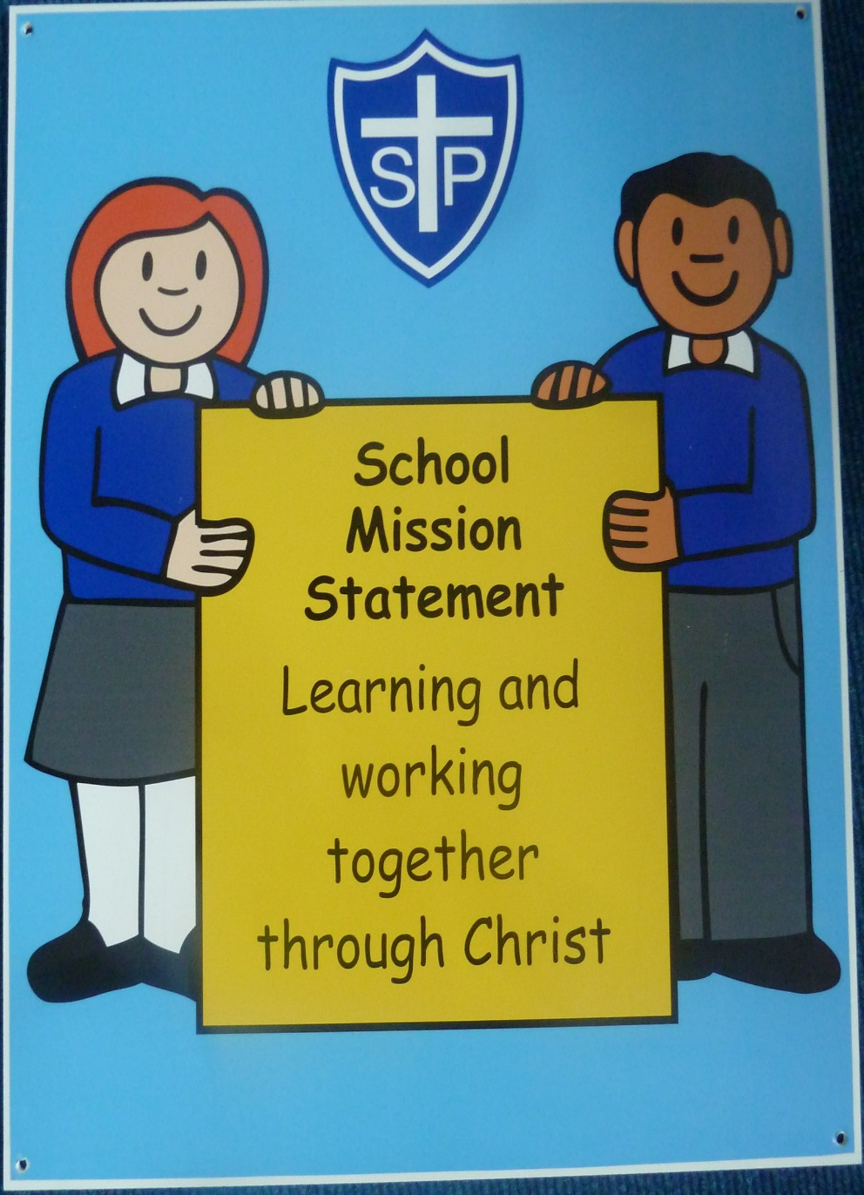

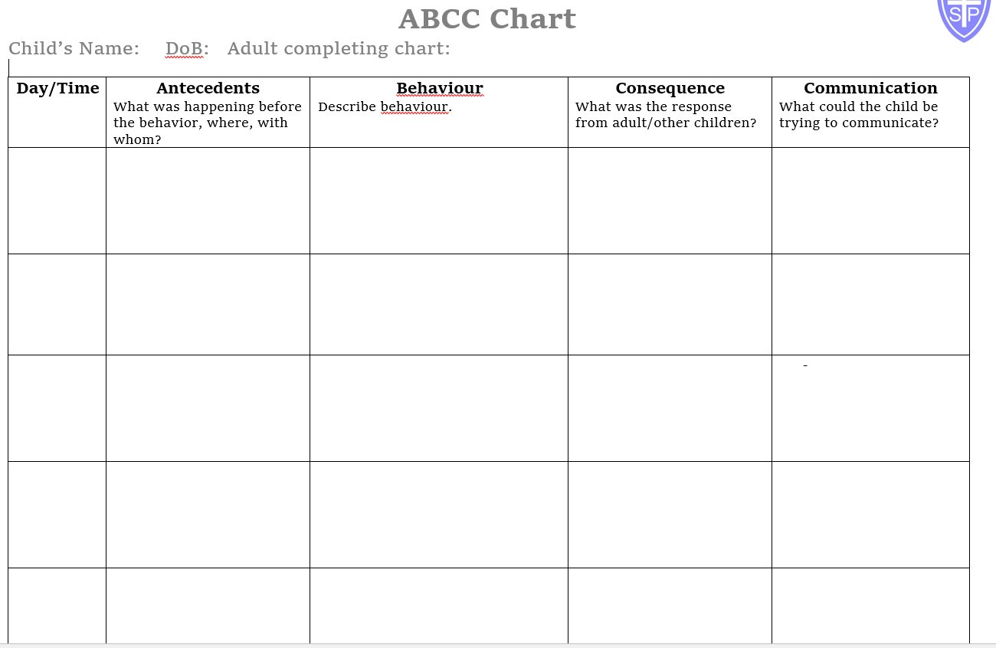

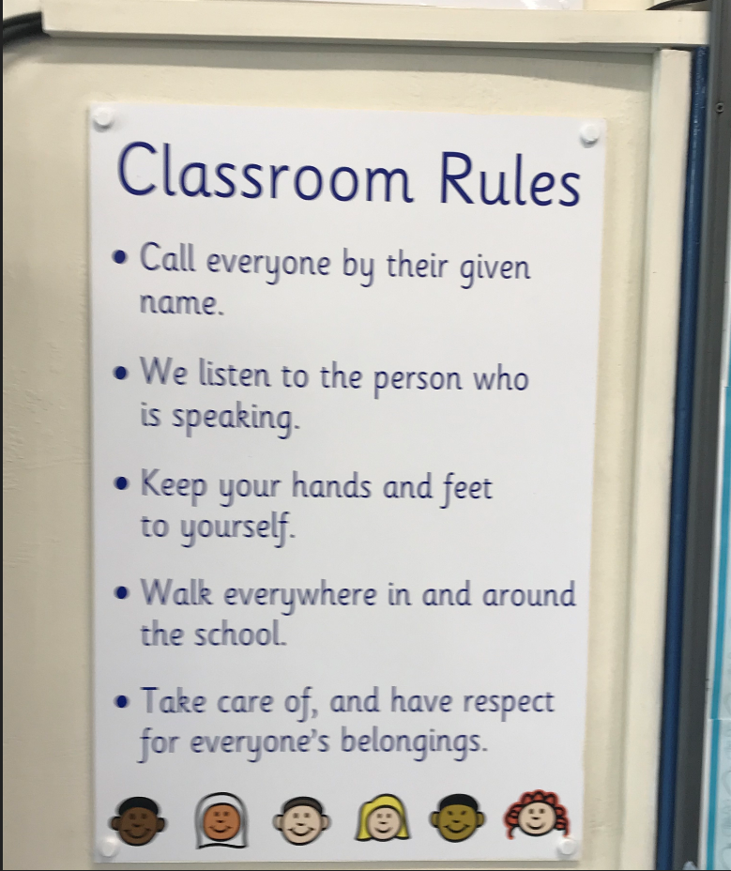

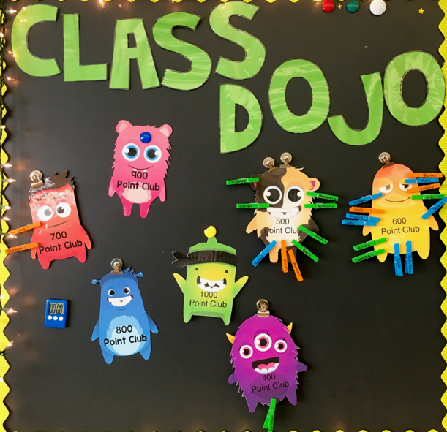

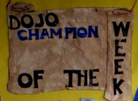
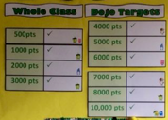

Addendum to Behaviour Policy in consideration to Covid 19: Coronavirus

In addition to the above, the following will be adhered to:

- All children will adhere to any altered routines for arrival or departure.
- All those in school will follow instructions on hygiene, including regular handwashing and sanitising at key times throughout the day.
- All children will adhere to learning and socialising with their class bubble throughout the day at school.
- All children will adhere to specific instructions for moving around school such as the use of one way systems and out of bounds areas
- Children will understand and follow expectations about sneezing, coughing and tissue disposal which are in line with the ‘catch it, bin it, kill it’ message.
- All children to make an adult aware if they are experiencing Coronavirus symptoms.
- The children will not share any equipment or other items such as water bottles.
- All children will follow guidance set out by amended expectations about break and play times, including playing within specific zones and where children may not play.
- All children will follow the clear rules about coughing or spitting at or towards any other person. All children will also follow encouragement to cover their mouths and faces when sneezing or coughing and follow the ‘catch it, bin it, kill it’ rule.
- Where a pupil does not follow the rules which address health and safety and pose a risk to others, parents will be informed and the child may be unable to return to school.
- Clear rules are shared with pupils at home about their conduct and behaviour in relation to remote education.
- The school rewards and sanction systems will continue where appropriate.

